Eliminating Corruption in College Sports
By: Angelo Cigarroa
Numbers don’t lie. Within the past decade, cheating scandals in college are at an all time high and have been increasing each year. The scandals are affecting all of college sports such as football basketball baseball etc. Each sport matters in this issue because corruption in college athletics affects every program at every school. The NCAA is the association that is in charge of penalizing coaches or players that break the rules in college sports. It is important that the NCAA becomes stricter and start enforcing the rules. By enforcing the rules more harshly coaches and players will think twice before thinking about cheating.
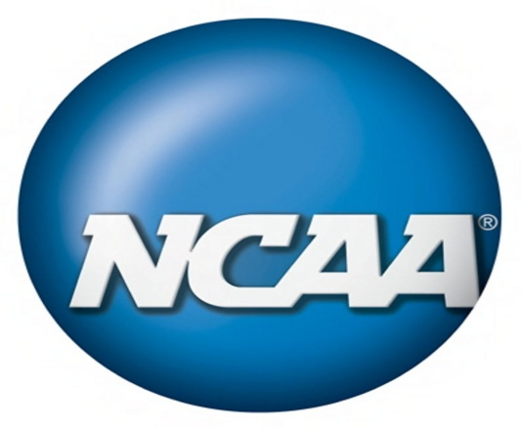
The NCAA is constantly updating rules and regulations because coaches and players continue to find ways on cheating the system by bending the rules. Due to the rapid increase in internet use, the NCAA constantly adds rules in which coaches contact a player, however these rules still continue to be broken. The NCAA is too lenient when it comes to coaches and players breaking the rules. Each college is different but each college must follow the rules that NCAA make. Coaches repeat themselves by breaking the same rules over and ever because they are not afraid of the punishment that they will be charged with. One of the most recognized schools known for cheating is Arizona States baseball program. ASU baseball team is considered the power house school at the colligate level. They have been caught cheating but yet only minor punishments such as “Last December, it was penalized for major secondary violations, resulting in three years probation and a one-year ban from NCAA postseason”. This is one of the many examples that show how lenient the NCAA is when it comes to punishing coaches that break the rules. By letting coaches get away with cheating it increases the amount of corruption in college sports because the problem is not being fixed it is just being temporarily evaluated. By this I mean issues don’t go away because you’re not getting rid of the people causing them. These types of patterns in college sports must be fixed so they stop occurring.
My point of view on the issue is the only way to fix the corruption is by reducing the chances a coach receives. I would call it the 3 levels to termination. A coach gets a total of 3 chances to learn from his mistakes and if he or she passes the 3rd level mark they are banned from coaching at the college level for life. This would put an end to the trend of coaches breaking the rules over and over again. This structure of terminating coaches gives 2 warnings before getting the ultimate punishment, and it will set an example for other coaches that are considering breaking the rules. Just by evaluating the amount of corruption, things are only getting worse. I believe if the NCAA does not enforce a 3 level rule there will be no change. The 3 level rule will not only get rid of cheating coaches but it will give more opportunity to those who don’t cheat and at the same time warn other coaches to clean up their act.

References
NCAA Regulations 4/28/11 http://compliance.lsu.edu/PublishingImages/NCAA%20Logo.jpg
10 Most Corrupt NCAA Programs March9th, 2011 http://www.ncaagridirongab.com/2011/03/09/10-most-corrupt-ncaa-athletic-programs/

